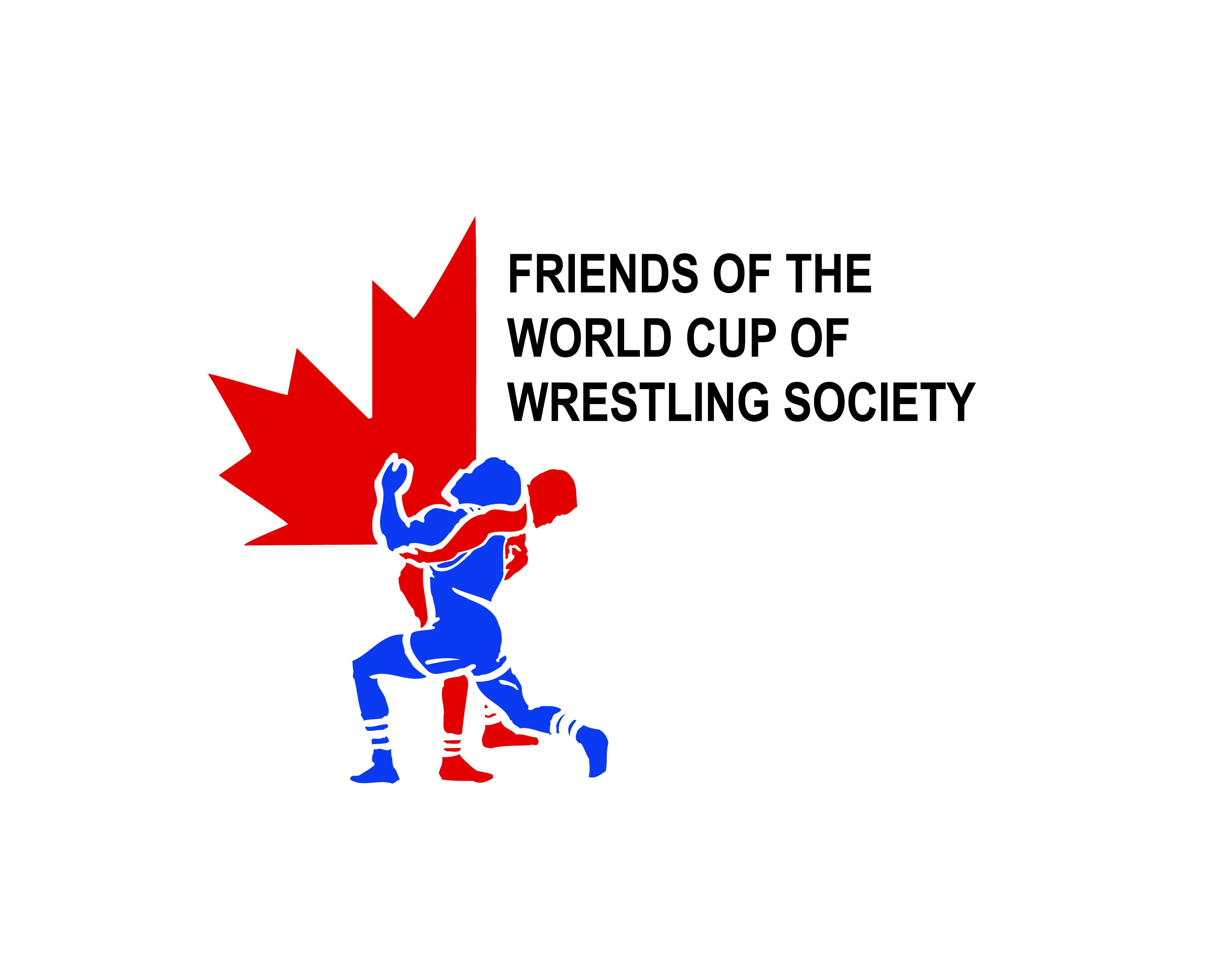

FRIENDS OF THE WORLD CUP OF WRESTLING SOCIETY

2015 Annual General Meeting

Broadmoor Golf Course, Sherwood Park AB

August 24, 2015

|  |  |  |
| --- | --- | --- |
| Members: | *Dave Campbell* | *Al Boychuk* |
| *Russ Pawlyk* | *Ken Lelacheur* | *Jerry Derewonko* |
| *Vang Ioannides* | *Kelly Rich* | *Chris Huebner* |
| *Bill Dowbiggin* | *Hayley Smith* | *Michael Payette* |
| *John Alock* |  |  |
| Guests: |  |  |
| *Suzanne Wilson* | *Denis Franklin* | *Natasha Beech* |

1. Call to Order.

*After Kelly Rich (Secretary-Treasurer) confirmed that member attendance satisfied the requirements for a quorum, and confirmed that the notice and information had been properly circulated to members, Russ Pawlyk (President) called the meeting to order at 6:15 PM.*

1. Additions to and Approval of the Agenda.

*Motion to approve the Agenda as presented (Dowbiggin / Derewonko).* ***Approved.***

1. Approval of Prior Year’s AGM Minutes.

*Motion to approve the 2014 AGM minutes as circulated and presented (Derewonko / Smith).* ***Approved****.*

1. President’s Report (Pawlyk).

*Russ spoke to the upcoming Special General Meeting that will follow the AGM to consider the recommended updates to the FWCWS bylaws. Russ also highlighted the upcoming 2015 Canadian Team Trials, hosted and organized by the FWCWS, which will be Wrestling Canada Lutte’s selection event to identify athletes eligible to qualify for the 2016 Rio Olympic Games. It is expected to be a spectacular event and Russ noted that many of the members are engaged as volunteers for the event.*

1. Presentation of Financial Statements and Auditors Report (Rich).

*Motion to accept the 2014 Financial Statements and Auditor's Report as circulated and presented. (Rich/ Lelacheur).* ***Approved.***

1. Business Arising & New Business.

*None*

1. Elections of Directors and Officers:
   * + Determination on Number of Directors. - *Motion to set the number of Directors at 5. (Rich/ Alcock).* ***Approved****.*
     + President & Director*. – Russ Pawlyk by acclimation*.
     + Vice-President & Director. *. – Vang Ioannides by acclimation*
     + Secretary-Treasurer & Director. *. – Kelly Rich by acclimation*
     + Director. *. – Hayley Smith by acclimation*
     + Director. *. – Al Boychuk by acclimation*
2. Adjournment at 6:35 PM

* Next Meeting will be the 2015 Special AGM to be held following this meeting.